**Masterful Investor by Scott Doyen**

**1. Introduction**

* Masterful Investor provides a breadth of resources for the average adult, trying to better their financial position and maybe even attain financial freedom. With blogs & calculators dedicated towards long term investing, users can enjoy and learn at the same time.
* With blogs written by myself, I share my investing and personal finance journey as well as research analyzing different methods to boost wealth, reduce debt, or do both.
* The calculators tab will offer a dropdown to select different calculators. Some of these might include a mortgage calculator or all-inclusive rental property analyzer. Others might include index fund investing calculators. With calculators about debt, whether that is student loan or credit card debt, users can make a plan for their own lives. Others may include budgeting and financial independence as well.
* About Me & Contact Pages are geared towards learning about or reaching out to myself specifically.

**2. Design and Implementation**

Give a detailed description of the design and implementation of your project.

* In order to convert my design to the actual realization of the project, I immediately looked online to see if there were components, such as cards or jumbotrons that seemed to fit the design I was thinking of. As a result, I first looked at our Nucamp Website we have been building to see if I could leverage some existing code to make my life easier. Also, I went to getbootstrap’s templates to complete the structure. Through a string of snippets, I was able to fill in my own content, share some styling, and essentially complete each page. I believe as a developer it is very important NOT to reinvent the wheel but utilize the breadth of resources available at your doorstep.
* My initial design was supposed to have a ‘subscribe to my newsletter’ on top of the navbar, but I ultimately decided against it, and actually added a video background with a tent on top of a mountain to encapsulate the idea of ‘Mastery’, a central theme to the website. I had substantial difficulties with the content to fill the design I had conceptualized previously. Ultimately, I will later go on to populate the website with more content as it comes to me, but the structure is there.
* Some components I elected to go with included the video background & the cards on the front page highlighting recent blog posts. As the project moves forward, I hope to dynamically populate this area with the most recent posts (React?).
* I chose these cards for snapshots of blogs instead of list groups due to the visual display and ease of responsive design. After viewing many other blog-like websites, I felt that it was the best choice & I was comfortable using them since we did so in our project. I added jQuery code to the cards that will take you to the respective blog post if you click anywhere on the card corresponding to a certain blog post.
* The links for the most part all work and take you to the correct pages etc.
* About Us & Contact pages are modeled after our Nucamp Projects.

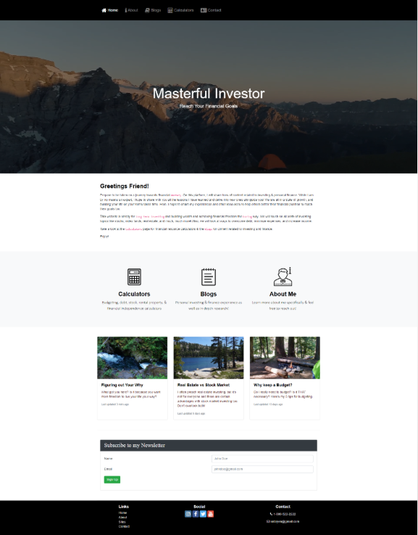

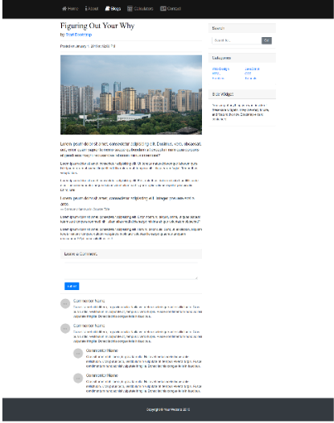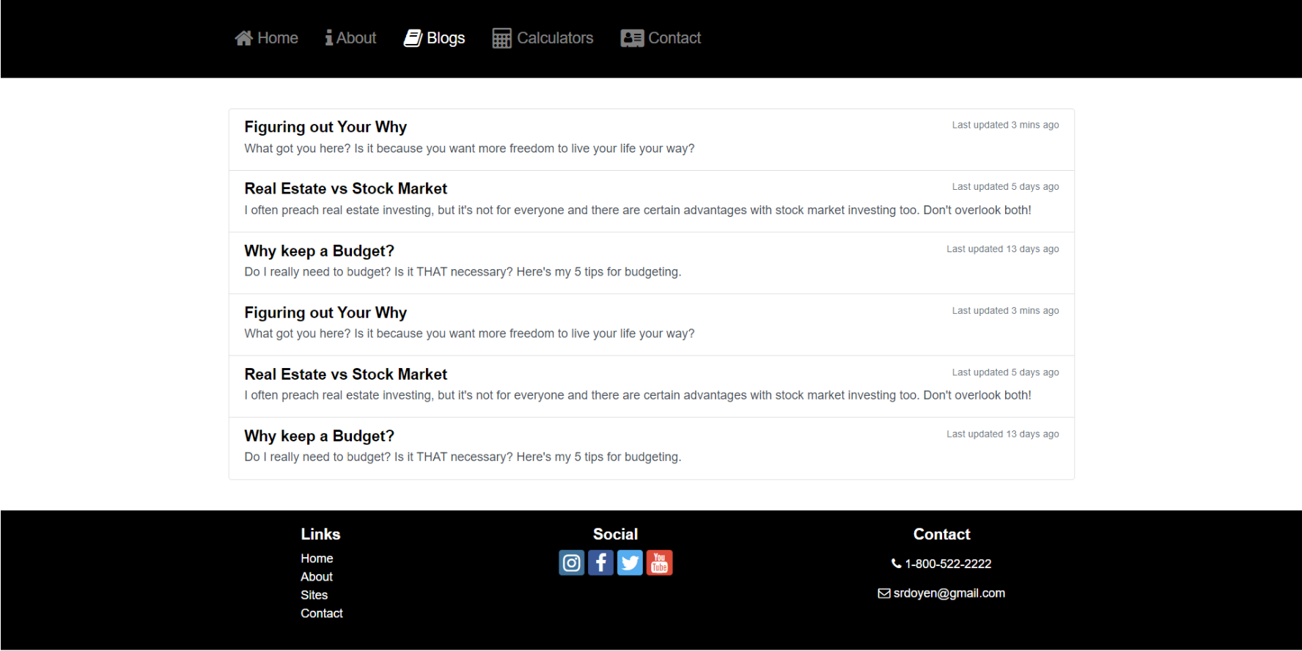

**3. Conclusions**

* For me, the most challenging aspects include the design. I had a hard time with the visualization and layout. It took me days searching and viewing other websites to get an idea of different layouts, before putting together something presentable in my head. I find that once I have a certain design in mind (often by looking at others’ ideas), I can implement it. For me, the implementation part is more of just asking the right questions, online and otherwise, before I find the code necessary to bring the design to life. Another challenging part includes making the website responsive to ALL platforms, specifically mobile. This was a big challenge as I had to constantly make sure it looks good on all viewport sizes.
* One of the best features of the project would be the home page. It has a sleek feel to it that flows well with the investor/finance content. Keeping it simple with black, white, gray colors was a choice taken purposefully to mirror the cool, calm, and collected attitudes that long term investors attain. In addition, I felt like the video background at the top is a terrific hook to my platform.
* Some shortcomings would include parts of the layout – specifically in the middle of the home page between the icons and the blog post snippets. I still think I will go back and re-arrange, add, or change that section because I don’t like the consecutive set of 3s.
* Some things I would have made differently would include the layout that I highlighted in the above bullet point. I think I would add an image or re-arrange slightly to have the page flow better when the user scrolls down.